

SCHOOL OF SCIENCE AND TECHNOLOGY
SYSTEM ANALYSIS AND DESIGN
MODULE CODE: SOFT40091

Design and Usability
SUBMITTED
BY
PURNIMA MALNEEDI
STUDENT ID: N0768969
SUBMITTED TO
Dr Amir Pourabdollah

Submission Date: 11-01-2018

Contents

Introduction 3
1. Task 1: Structure Chart 4
2. Task 2: User Interface Design principles 7
3. Task 3: User Interface Design process 11
4. Task 4: Usability and User experience Goals 16
5. References 18

Introduction
This report describes the design and usability of the new system.
Structure chart created to describe the components of the new system for two processes. Also given explanation for key elements of structure chart and steps required drawing the structure chart. Explained types of structure chart as well.
A sample UI has been presented addressing the all user design principles. Final Interface design produced with providing some user scenarios, Interface structure design, and Interface prototyping and evaluation technique. Clear explanation given for all the steps in User interface design process.
Finally examples of usability goals and user experience goals provided.

Task 1: Structure Chart
The structure chart is one of the popular techniques used by analyst in program design for the new system. This is normally a breakdown of system in to lowest manageable levels. Structure chart consists of different high level program modules arranged into a tree structure. Each module represented by a box with module name and a sequence number which indicates the program flow. Structure chart also represents selection criteria for each module that is invoked and shows the iteration in case the module is repeated [1][3].
A structure chart is always read from top to bottom and each module is numbered in hierarchical numbering format. Structure chart usually derived from the DFD (data flow diagram). Structure chart represent the new system in to smaller parts, so it helps the programmer can easily understand the problem/requirement. Analysts draw this diagram in the design phase, will be used by programmer and business users to communicate the problem and see the solution up front [3].
The structure chart shows below key things
- Size and Complexity of the new system.
- Number of modules and function that can be easily identifiable.
- Breakdown of module/function into smaller parts if it not manageable.
Structure Chart Elements:
There are varieties of elements used in Structure chart to define each function/module and its relationship. The below diagram shows all the Elements and its purpose, symbol.
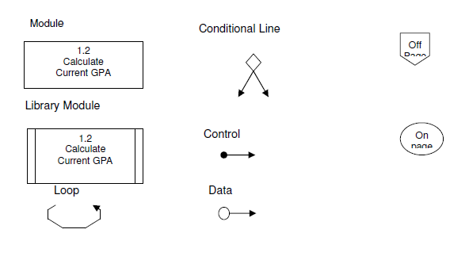
Figure 1.1. System Chart Elements (3)
Each element explained below
Element | Purpose
Module | Represents a logical piece of program [1]
Library Module | This also represents logical piece of program repeated more than once
Loop | Indicates if the specific task is repeated
Conditional Line | Indicates that sub modules invoked based on some condition [1]
Data Couple | Data movement between modules [5]
Control Couple | Indicates a message or flag passed between modules
Off-page connector | Indicates when structure chart continued on another page [1]
On-page Connector | Indicates when structure chart continued somewhere on the same page [1]
There are two types of structure charts
- Transaction structure: This structure contains one control module that calls subordinate modules. Each subordinate module handles specific transaction [1].
- Transform structure: This structure contains one control module that calls subordinate modules in sequence. Each subordinate module takes an input and process that as an output to the next module [1].
As discussed above structure chart drawn from the processes used in the DFD. Each process in the DFD represents one module [5]. Based on the processes used in the Thomson Cycles DFD the below basic structure chart has been drawn with the additional modules (Website orders) required for the Thomson cycles new system.
Thomson System basic structure chart modules:
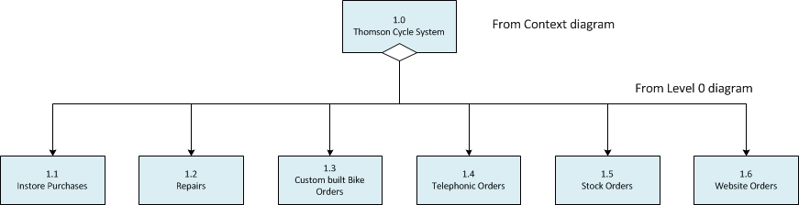

Some steps should be followed to draw a Structure chart. Please find it below
1. Identify the control module, subordinate modules and break it into lower levels if required.
2. Add Control and Data couples between the modules.
3. Add required conditional lines and loops.
4. Review and revise the chart again until its fully completed [5].

There are two structured charts drawn below for two of the main processes in the new system.

Telephone Orders Structure Chart:
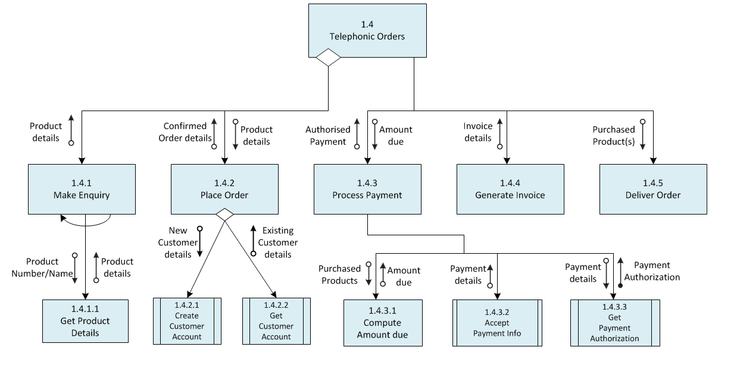
We can see that telephonic orders have got conditional line to its sub-ordinate modules ‘Make Enquiry’ and ‘Place Order’. This is because a customer can make an enquiry about the product but no guarantee that the customer can proceed with purchase of item. Also if the customer knows exactly what he wants to buy then customer purchases the product without doing any enquiry. Make Enquiry has got loop on it, because customer can enquire about more than one product so in this case it should be repeated. To purchase or enquiry about products customer need to give product details so that data couple has been added between the modules. ‘Accept Payment Info’ is the module will be used by all processes to take the payment detail from the customer so it is represented as Library module. Once customer made the payment then payment system sends the authorization flag back to confirm whether payment success or not, so Control couple has been used.
Similar to the above structure chart drawn for website orders.
Website Orders Structure Chart:
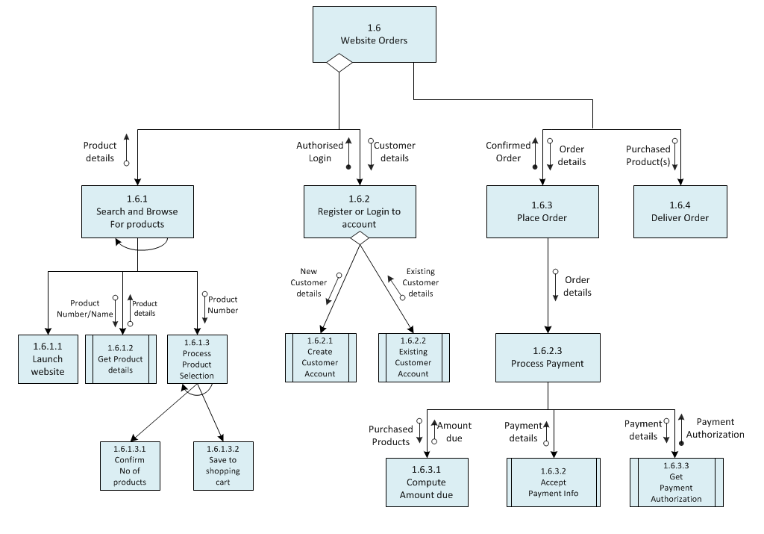

Task 2: User Interface Design principles
User interface is the graphical representation of front end view of the system where the user interacts with the application to use the new software developed. Through this interface only user can do all the functions. In the present world UI almost exist everywhere from small products like mobile phones and audio devices to the big products like cars, flights etc. It provides basic platform for the user to interact with the computer system [2].

These days any application or software will be more popular if the User interface is:

- More attractive to the user
- Very simple to use [2]
- Less responsive time to access the application
- Very clear instructions to use the system
- Easy to understand
- Consistency across all UI screens [2]

The sample User interface for Thompson Cycle website drawn below.
Thomson Cycle website sample UI design:
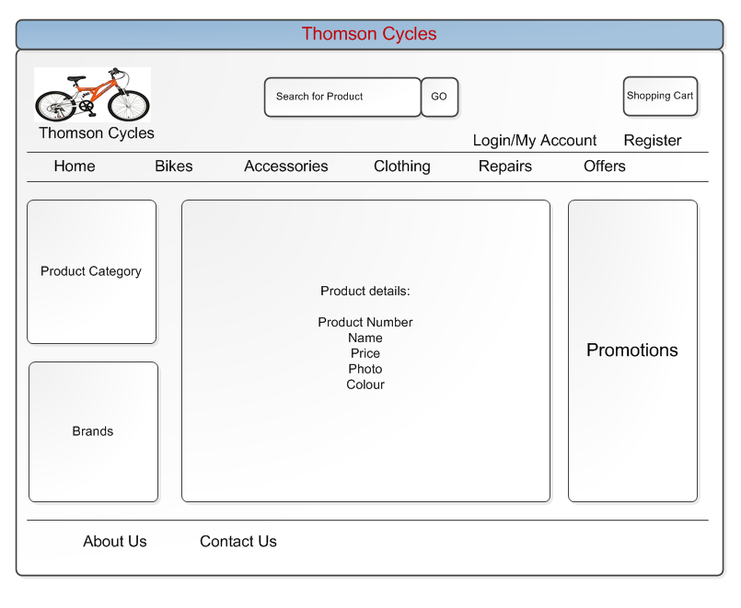
User interface design is an art and it should be very good looking and easy to use. Designers always faces difficulty while producing the design, they always uses more space to present the information. So Analyst should take more care when designing the user interface. There are some basic principles that should be followed for better user interface design.
User Interface Design Principles:
- Layout
- Content awareness
- Aesthetics
- Usage level
- Consistency
- Minimize user effort

Each of the above principle explained in detail below.
Layout:
Layout is key principle for any user interface as this is the first thing that user sees when they access the system. Layout deals with the representation of front screen or form for the new application. This refers to the how well the screen is organized into multiple areas to accommodate different functions [1].
Layout consists of three areas Top, Middle and Bottom. Top area usually used to display the Logo and Menu options and to navigate to the different areas of the system. Middle area is to display the main content of the system. This is the largest area in the layout where it displays the user work. Bottom area shows the user status or general information about the system or company. Similar kind of areas should be grouped together. All areas should be used to minimize the user efforts to access any function [1].
The above sample UI for Thomson cycle website shows the multiple layouts for different functions. Top area shows the standard menu of the website like Home, Bikes and Accessories etc. using this area user can navigate to another layout area or screen. Top area also contains the user login/register function using which user will navigate to completely different page. Middle area of UI contains more than one layout. Left side of the layout area displays different categories so that user can easily search the required product. Centre area of the middle layout shows the information about the product. Right edge area of the middle layout shows the promotions to the user. Bottom area shows the contact information and Company information. Using this user can quickly see contact info in case if they need any further information.

Content awareness:
‘Content awareness’ name itself represents that the each interface element should have the clear information to the user. It doesn’t matter whether its Menu item or navigation or search input, every part must display the as much as clear content to the user. But this is more important for the website forms where most front end users not aware of much about the website unlike the actual back end users (employees).
To satisfy this principle every interface should be named with a title. Menu options should display that where the user currently is and where they came from. Also I make sure that the information in each area is clear to the user without giving any confusion. For example product description area should be clear with all the information about the product.
Fields and field labels also should be taken care within each area. Filed labels are used to find the fields, so it should be short and not conflict with other labels. If we think any fields has got some kind of ambiguity then give clear explanation. Also field’s format and information should be consistent. It is good to put dates and version number on each form [1].

Aesthetics:
This principle refers that the UI should more pleasant to the user eyes. Pleasing Interface is not just enough; it also should be functional and invite the user to use the application. Simple design is always best, using more space and more detailed information will make the form unpleasant. Keep as minimum amount of white space between the forms and avoid using big sizes of the text.
In my sample design I have taken care of these things and designed the web page with white background to give the pleasant feel to the user. And unique font and colors used for all the fields and labels across all forms. Capital letters avoided in the UI [1].

Usage level:
This refers to level of usage of the application by users. Usage Level states that interface design also considers the user experience with the computer. In general system will be used by the people who have got more experience to the system or some people will have no experience. So UI should be designed to both types of users.
Less experience (Beginner) users are mostly looks for how quickly they can learn to use system. So I have made my design by putting menu with all the functions available because menu options help these users to easily learn the system [1].
Experienced users concerns about the how quickly and easily they can do certain task. For these users categories and brands has been put in the design to quickly access any function.
At the end both users look for the similar function in a different way.

Consistency:
This is most important principle that makes the system simple to use. If the UI is consistent across the other interfaces and other systems then user can easily guess what will happen next which will reduces the user efforts on learning.
Consistency also refers to the interfaces to make sure that all parts of the application functions similarly. And also system should be consistent across all other systems in the company.
Consistency arises at various levels as below.
- Navigation Controls - Tells how the actions should be performed consistently
- Terminology - All elements in the interface should have the same words
- Forms and report design – Make sure that forms and reports similar but not too consistent [1]

Minimize user effort:
This refers to the amount of effort that user needs to finish the tasks. Minimizing the user efforts can be accomplished by less number of mouse clicks to move from one part to another within the system.
Mostly designers follow 3 click rules for UI design, this means that user should be able to do any action or get the information from home menu with in 3 mouse clicks. In my design I am ensured to follow this rule [1].

Task 3: User Interface Design process

The user interface design plays crucial role in any software system success. It doesn’t matter how good is the product idea behind the system or what technologies used to develop. Product will be failed if the design is not good and confused for the users to use. A product should be developed for the front end users not for the business owners. A good UI design differentiates between the successful and failed product [6].
User interface design is an iterative process. There are 5 steps that should be followed for affective design. These steps can be followed in any sequence there is no strict rules about how analyst follow this. These 5 steps are as follows and also displayed in the below diagram.
- Use scenario development [1]
- Interface structure design
- Interface standards design
- Interface design prototyping
- Interface evaluation

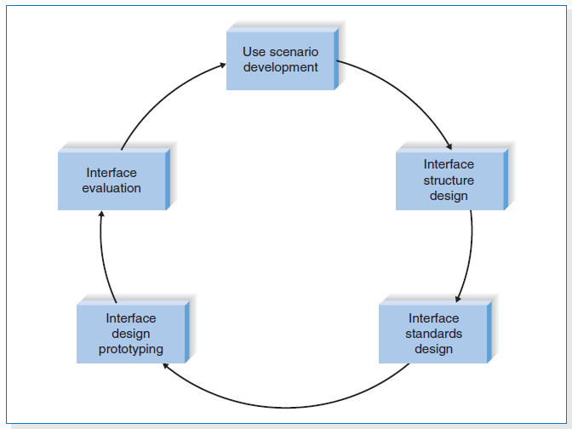
Figure 1.2. User Interface Design Process (Dennis, A., Wixom, B. and Roth, R. (2015).)

Use Scenario development:
User Scenario is a detailed description of the steps that user performs to accomplish specific task. This is usually a one path through the use case with more information, but should be relevant to the user experience of the product. User scenario outlines the user’s motivation and purpose of visiting the website or system [7].

A perfect user scenario gives the simple story that describes the background of the product usage. It explains some of the most important question as below
- Who is using the product?
- What does the user want to do with the product? [7]
- How does the user complete their goals?
There are two use scenarios explained below for the two processes.
- Online Shoppers:
Use Scenario: The Slow Shopper
Slow shoppers normally take more time to buy the products in online. They don’t have any particular wish list to buy. These users simply explore the website to find the variety of products with associated brands. They will purchase only when they find the correct one.
- User opens website and search for different categories and products.
- Randomly surf most of the products in website.
- Choose the right product and add that one to shopping cart and carry’s on with surfing website catalogue.
- Surf other categories and also add those products to cart list.
- Once exploring the catalogue users checks the shopping cart and start comparing prices and review of the products.
- Depends on budget of user, will choose only required products and not required will be removed from cart.
- Continue to check out the products in shopping cart through providing valid user details. If he is new user then proceed to the registration.
- Proceed with payments and logouts

Use Scenario: The quick Shopper
Quick shoppers normally take less time to buy the products in online. They have particular products to buy. These users surf website to find the required products with associated brands. They will purchase only they find the specific product that they want.
- User opens website and search for required categories and products.
- Choose the product they looking to buy and add that one to shopping cart.
- Continue to check out the products in shopping cart through providing valid user details or register if the user not registered before.
- Proceed with payments and logouts
- Telephone sales for repairs and Customer bikes shoppers:
Use Scenario: The Confused Shopper
This kind of shopper is completely not aware of the required products which use for the repairs or to build a custom bike.
- Shopper calls the customer service agent.
- Ask for the different variety of products available in shop.
- Get all product details and prices of available products.
- Based on the available budget customer may choose or may not choose the products to order.
- If user chooses the product provides the delivery and details of user to customer service agent and also provides payment details over telephone.
- Hangs up the phone.

Use Scenario: The clarity Shopper
This kind of shopper is completely aware of the required products which use for the repairs or to build a custom bike.
- Opens website and randomly see all the products.
- Shopper calls the customer service agent.
- Ask for the availability and price of the product that the shopper is looking for.
- Based on availability of product customer orders it.
- Provides the delivery and details of user to customer service agent and also provides payment details over telephone.
- Hangs up the phone.

Interface Structure design:
Interface structure design describes the basic components of the user interface and shows how all components work together to provide some functionality to the system users. ISD shows all the forms, reports and screens used and how they related to each other. It also shows how the user moves from one component to another component. One system usually contains more than one ISD [1].
ISD is quite similar to data flow diagram because both use boxes and lines to display the structure, but there is no set of rules to draw the ISD. Each element in ISD is represented by a box with unique number. All the interfaces are linked by using the lines which defines the user movement from one to another.

The Interface structure for the major part of the website is shown below.
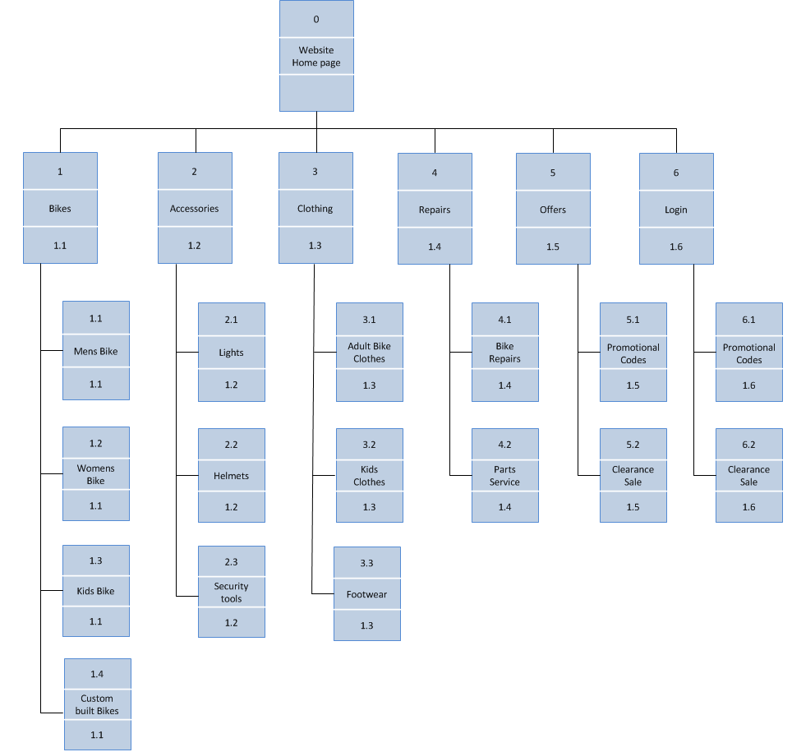

Interface Standard design:
These standards are the design elements that are common between the individual parts of the interfaces which can be screens, reports or forms. Different parts of the system can have Interface standards can have more than one set of standards. For example screens can have different set of the standards than reports. These standards can also be based on function of the particular part. For example web screens can follow the standardized web format. Interface standards help to set the benchmark for the designers to ensure that all the interfaces are consistent within the system [1].

There are different types of standards that are shown below.
- Interface Metaphor - This is a concept which taken from the real world(example: shopping cart)
- Interface objects - These are entities and data stores used in the interface [1]
- Interface actions - Names for the navigation control
- Interface template - Defines the layout guide for all parts of the interface
- Interface icons. - These Icons are pictures represents the interface objects and actions [1]

Interface design prototyping:
Interface design prototyping is nothing but a replica of a screen, report or form in the system. All the interfaces should have the prototype to illustrate how the system will perform for the programmers and users. As the technology grows there are several tools used to build the prototypes but in past prototypes listed on the paper [1].
There are 3 most important methods to build interface design prototypes are explained below.
- Story boards:
This is paper based prototype. Story board contains pictures drawn by hand on a paper for all screens and movement between the screens. This is very simple technique used in olden days. It requires someone who should be good artist to draw good looking pictures and diagrams.
- HTML prototypes :
This is most popular technique used by most of the designers. Similar to the story board this prototype also shows the pictures of all screens or web pages. But the difference is here all the web pages created by using HTML. HTML is hypertext markup language used to design web pages. Using this functionality can be presented to the user where user can click some buttons and can enter the data into forms but this data won’t be processed. This helps the user to better understand the system [1].
- Language prototypes:
These prototypes are also similar to the HTML prototypes. The only difference is language prototypes developed by actual tool or programming language that will be used to build the original system. This prototype also provides only the visual appearance of the real system without processing the data. This prototype design takes longer time and expensive. However this will show the exact screens of the system so that user doesn’t have to guess [1].
Interface evaluation:
The main objective of this is to understand how the interface design can be improved. There are no set of methods that assures the good user interface. In general designers produce an interface design that suits their personal preferences but may not be liked by the users. So it is recommended to have more number of people involved in the evaluation of the interface, prefer at least 10 users says by the experts [1].
Instead of waiting until the last step of SDLC it is ideal to perform Interface evaluation at the design stage. So that we can address any major problems that are identified in the design and can be corrected before the system is built. It is very common to do one or two changes to the design when user sees the interface for the first time, because users may find some problems which are noticed by project team [1].
There are 4 different approaches to evaluate the interface as below.
- Heuristic evaluation
- Walk-through evaluation
- Interactive evaluation
- Formal usability testing

Task 4: Usability and User experience Goals
In a simple terms Usability is a quality attribute that focuses on usage of the interface to determine how easy to use the system [9]. User experience refers to the human emotions about the presentation, performance, accessibility and functionality of the interactive system. User experience and usability is shown in the below diagram where it divides into utility, usability, appeal and brand experience [8].
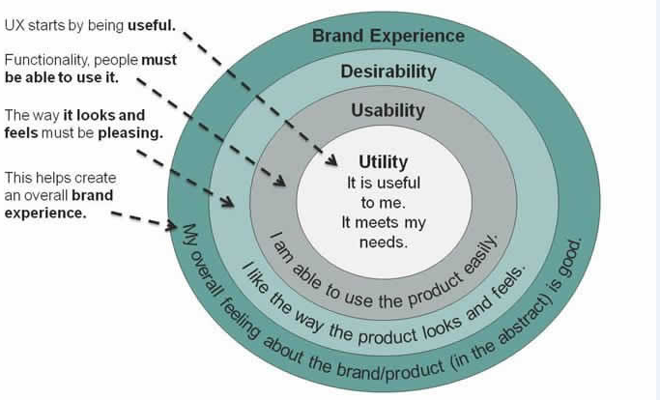
Figure 1.3. User Experience diagram (Usabilitygeek.com. (2018))
Usability goals:
Usability goals refer to how effectively system is functioning. User should be comfortable, less confused and understands the system usage.
There are six components of usability are explained below.
- Effectiveness: This represents the accuracy and completeness to achieve a specific goal for the user [10]. I have taken care of some measurements in my system for the user to get the information quickly and easily.
- Learnability: This refers to the how easy to learn the system. As this is a new system it should be simple to use. I have taken care of this by following consistency across the interfaces so that user can easily find everything.
- Efficiency: This refers to the number of steps taken by the user to complete a specific task. If the more resource used then it means that user takes more time to finish the task. I have followed 3 click rule in my design for more efficiency.
- Memorability: This refers to the how easily the user can remember the system after their first use.
- Errors: This refers to the number of errors encountered while user attempting to complete a specific task [10]. Ultimately system should be error free, but in case of error clear information should be given to the user for further guidance.
- Satisfaction: User satisfaction is overall feeling of the user about the system. This can be measured by taking feedback from user through some standardized satisfaction questionnaires [10]. We can monitor this at any time.

User experience goals:
User experience refers to the user overall feeling about the system with usage, look and feel. There are wide variety of user experience goals which is either positive or negative.
Positive experience means that user is happy about the system. There are some positive user experience goals shown below.
- satisfying
- enjoyable
- engaging
- pleasurable
- exciting
- entertaining
Negative Experience is something which user doesn’t like about the system. The below are some user negative responses.
- Boring
- Frustrating
- Annoying
- Childish
- Un Pleasant

References

- Dennis, A., Wixom, B. and Roth, R. (2015). System analysis & design. 6th ed. Hoboken, NJ: Wiley.
- www.tutorialspoint.com. (2018). Software Analysis & Design Tools. [online] Available at: https://www.tutorialspoint.com/software_engineering/software_analysis_design_tools.htm [Accessed 7 Jan. 2018].
- Revolvy, L. (2018). "Structure chart" on Revolvy.com. [online] Revolvy.com. Available at: https://www.revolvy.com/main/index.php?s=Structure%20chart [Accessed 9 Jan. 2018].
- Enggpedia.com. (2018). What is a structure chart? What are the Elements of a structure chart and types of structure chart? - Engineering Questions Answers QnA - Agricultural, Electrical, Civil, Computer, Mechanical. [online] Available at: http://www.enggpedia.com/answers/2064/structure-chart-elements-structure-types-structure-chart [Accessed 9 Jan. 2018].
- Dunphy (2018). Representational Tools. [online] Slideshare.net. Available at: https://www.slideshare.net/ldunphy/representational-tools [Accessed 10 Jan. 2018].
- Intetics. (2018). The Main Steps of The User Interface Design | Intetics. [online] Available at: https://intetics.com/blog/the-main-steps-of-the-user-interface-design/ [Accessed 10 Jan. 2018].
- Ghazarian, A. (2018). User Stories and Scenarios in UX Design - Designmodo. [online] Designmodo. Available at: https://designmodo.com/user-stories-ux/ [Accessed 10 Jan. 2018].
- Usabilitygeek.com. (2018). [online] Available at: https://usabilitygeek.com/the-difference-between-usability-and-user-experience/ [Accessed 11 Jan. 2018].
- Peacock, M. (2018). The Difference Between Usability and User Experience. [online] CMSWire.com. Available at: https://www.cmswire.com/cms/web-publishing/the-difference-between-usability-and-user-experience-006963.php [Accessed 11 Jan. 2018].
- Mifsud, J. (2018). Usability Metrics - A Guide To Quantify The Usability Of Any System - Usability Geek. [online] Usability Geek. Available at: https://usabilitygeek.com/usability-metrics-a-guide-to-quantify-system-usability/ [Accessed 11 Jan. 2018].

